Problem Statement

To predict the eye state (open or closed) from instantaneous EEG measurements using a Multi-Layer Perceptron (MLP) and to study how different architectural and training hyperparameters (optimizer, learning rate, hidden layer size, activation function, epochs, batch size) affect performance.

Multi-Layer Perceptron for EEG Eye State Detection
Dataset: EEG Eye State Dataset. EEG (Electroencephalography) is a technique for recording the brain’s electrical activity from the scalp using electrodes.
Source: UCI Machine Learning Repository
About: Contains EEG signal readings from 14 scalp electrodes, recorded over time.
Task: Binary classification, predict whether the subject’s eyes are open (0) or closed (1).
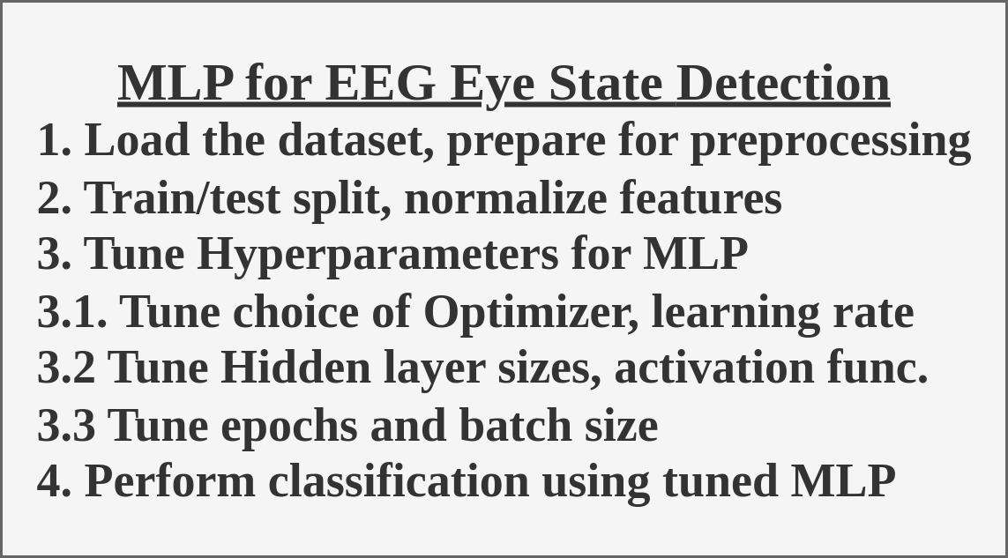

Workflow

1. Preprocessing
- Load the dataset.
- Inspect feature names, datatypes, and check for null values.
- Examine descriptive statistics of features and class balance for target variable.
- Split into features (X) and target (y).

2. Data Preparation
- Standardize numerical features to zero mean and unit variance.
- Perform an 80-20 stratified train-test split.
- Convert data into PyTorch tensors for model training.

3. Hyperparameter Tuning
- Optimizer Selection: Compare SGD and Adam at different learning rates to assess convergence speed and stability.
- Learning Rate Tuning: Test multiple learning rates for Adam ([1e-4, 3e-4, 1e-3, 3e-3, 1e-2]) to evaluate bias-variance trade-offs.
- Hidden Layer Size (First Layer): Vary number of neurons ([32, 64, 128, 256]) to assess impact on convergence and accuracy.
- Second Hidden Layer Size: With first layer fixed at 256, vary second layer neurons ([16, 32, 64, 128]) and compare performance at different learning rates.
- Activation Function: Compare ReLU vs Tanh for stability, convergence, and metrics.
- Epoch Count: Evaluate performance across different epoch limits ([50, 100, 200, 300, 500]).
- Batch Size: Test mini-batch sizes ([16, 32, 64]) to see effect on convergence noise and generalization.

4. Modeling
- Implement MLP with PyTorch:
  - Input layer: 14 features
  - Two hidden layers (tunable sizes) with chosen activation function
  - Output layer: single neuron with sigmoid output for binary classification
- Train the final MLP with best hyperparameters from tuning:
  - Adam optimizer, lr = 0.01
  - Batch size = 16
  - Hidden layers = (256, 128)
  - ReLU activation
  - Epochs = 50

5. Evaluation Metrics
- Accuracy, Precision, Recall, F1-score, AUC on test set.
- Plot training vs test loss curves for each tuning experiment.
- Visualize metric comparison across hyperparameter settings.

6. Comparison with Baselines
- Train and evaluate Random Forest, Decision Tree, and KNN on same data.
- Compare all models’ metrics side-by-side.

